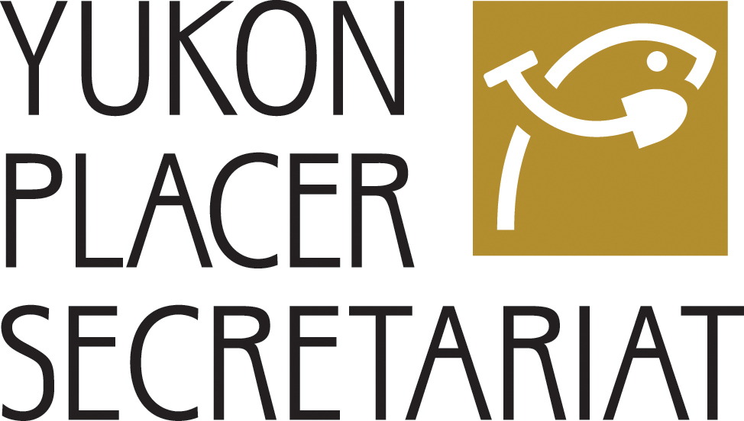

Fish Habitat Management System
for Yukon Placer Mining

Water Quality Objectives
Monitoring Report (2011)

Prepared by

The Yukon Placer
Water Quality Working Group

Revised February 6, 2013

WATER QUALITY OBJECTIVES MONITORING REPORT (2011)

The Fish Habitat Management System for Yukon Placer Mining replaced the Yukon Placer Authorization (YPA) in 15 Yukon watersheds on April 11, 2008. Founded on principles of adaptive management and incorporating a risk-based approach to decision-making, the system is intended to balance the objectives of a sustainable Yukon placer mining industry with the conservation and protection of fish and fish habitat supporting fisheries.

Adaptive management recognizes that the effectiveness of any management system is hampered by a degree of uncertainty and lack of knowledge. It seeks to improve the system by monitoring the effects of management actions, in order to learn from the results. The Adaptive Management Framework for Yukon placer mining is complemented by traditional knowledge and water quality objectives monitoring, aquatic health monitoring and economic health monitoring programs. The results should provide new information and a rational basis for making any adjustments required to achieve the two management objectives.

The water quality objectives monitoring program is governed by the Water Quality Objectives Monitoring Protocol. The Protocol describes the locations, timing, frequency and methods employed during sampling, as well as the methods used to analyze sampling data. Precipitation data was collected from a variety of sources to assist in the interpretation of results.

The water quality objectives monitoring program relies upon both continuous sampling and grab sampling. Continuous sampling is performed by automated instruments that pump water from the creek or river at a preset volume and at precise times each day. Grab samples are taken by personnel at a selected location, depth and time. Normally the quantity of water taken is sufficient for all the physical and chemical analyses that will be done on the sample. Grab sampling is also performed during sampling “blitzes”, when single grab samples are collected from as many sites as possible within a short timeframe in order to get a snapshot of the water quality in a watershed over a 24 hour period.

Fifteen watershed-based authorizations replaced the YPA in the Yukon River Basin. These authorizations contain a three year phase-in schedule for the sediment discharge standards that apply to each placer mining operation in the Yukon. This phase-in period allowed mining inspectors and the Yukon Placer Secretariat enough time to ensure that each operator fully understood the new regulatory requirements, and to make the physical changes necessary to achieve and maintain compliance at their site. The phase-in schedule contains the following requirements:

In 2008 – Licensed placer miners were informed about the operating practices required to comply with the new system for managing placer mining activity under the Fisheries Act. Inspectors and the Yukon Placer Secretariat did ensure that each operator was aware of the specific changes required at his or her site.

In 2009 – All licensed placer miners were to be oriented to the Design Target and Action Level detailed within the authorization pertaining to the watershed they were operating in and, must comply with a Sediment Discharge Standard for mine discharge of no greater than 2.5 ml/L, or the standard stipulated in their existing water use license, whichever is more stringent.

And in 2010 – All operations were oriented to operate within the Design Target and Action Level, and must not exceed the Compliance Level stipulated in the table of Sediment Discharge Standards for Placer Mine Effluent (Schedule 2) for the habitat suitability classification and the watershed in which the mine is located.

In 2011, water quality objectives were monitored in the Klondike River.

On those occasions when the WQO were not met and the Total Suspended Solids levels were greater than the objectives, a direct correlation between environmental conditions and the volume of solids in the water was observed.

In most cases, rain fall, either as localized events or basin wide occurrences, increased the amount of surface run off and subsequent soil erosion from the land, increasing the input of sediment into the receiving waters. These increases occurred simultaneously at the time of the rain event or immediately in a period of one or two days after the rain event, as surface water continued draining from the land and ground water infiltrated the water course.

The ability of the receiving water to dilute these inputs of sediment is negated by the re-suspension of stream bed material and by the further erosion of the streams banks that occurs along with the increased flows that are generated by the aftermath of these rain events.

These factors (precipitation leading to increased sediment input and increased flows from these rain events re-suspending and further eroding material) led to an increase in suspended solids concentrations in 2011 when compared with the results from 2010 and a very slight decrease in overall water quality.

A more detailed description of the monitoring results for the watershed is contained in this report.

