Skype for Business at Home
This document will cover how to download and sign in to Skype for Business on your personal computer.
How to Download:
- Open your preferred web browser, such as Chrome or Internet Explorer
- Click the URL bar and enter: https://products.office.com/en-ca/skype-for-business/download-app
- The download button pictured below will be displayed—if you don’t see it, you might have to scroll down.
- Click “Download licensed client”
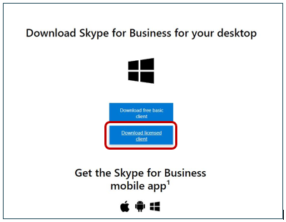
NOTE: When you click the Download button on the page, you will be prompted to Sign in with your YG Microsoft account.
- Log in with your usename@ynet.gov.yk.ca and enter your Password
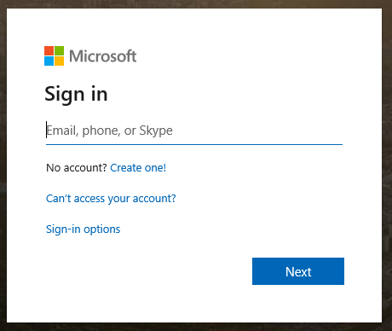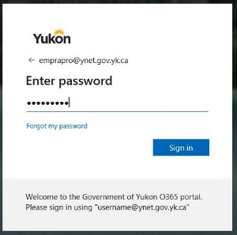

- You are now in https://portal.office.com/account#installs
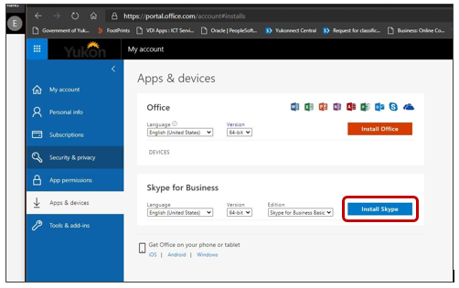
- Click on Run, at the bottom of your page
- Accept the license agreement
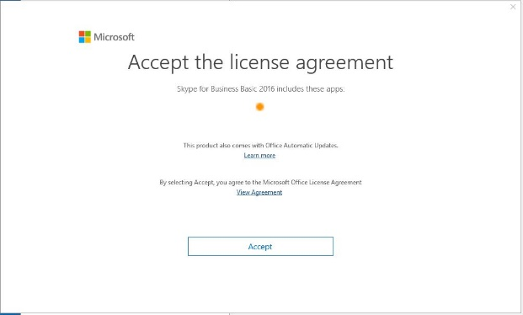
- Close when you’re done
- You should have Skype for Business in your list of programs (Start button)

How to Sign In:
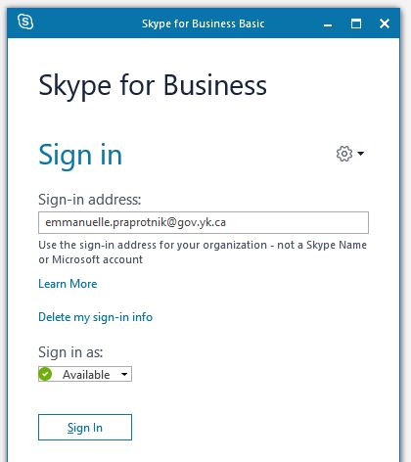
- Open Skype for Business
jane.smith@gov.yk.ca

- Sign in using the following format: “FirstName.LastName@gov.yk.ca” and enter your password
For example, an employee named Jane Smith would enter: jane.smith@gov.yk.ca
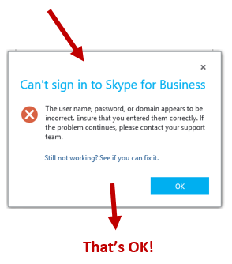

Didn’t work? That’s ok!
Just a couple quick steps to fix it!

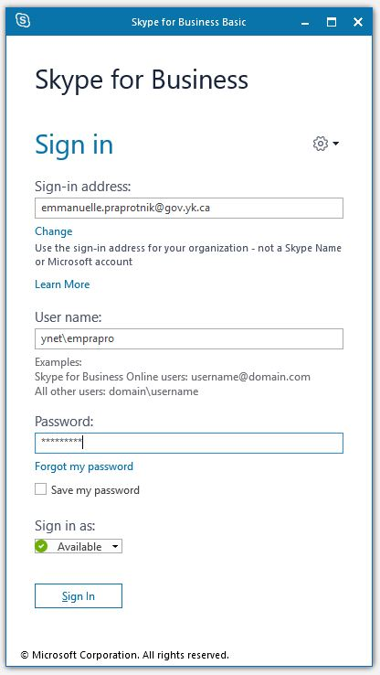
- Change the User Name
to the following format: “ynet\username”
and enter your password
For example, an employee named
Jane Smith would enter: ynet\jsmith
Note: in case you have a blank (white) window instead of a Skype window, you have to restart your computer
jane.smith@gov.yk.ca
Ynet\jsmith

