Virtual Desktop Client Install:

Click on the link below or put the address into the address bar to get to the install location select “Install VMware Horizon Client” and select the operating system for the computer you are installing the client on. In most cases this will be the Windows Client and for most new computers it will be the 64 Bit client...if this does not work try the 32 bit client. When it installs it should ask you for a server name to connect to and this is “horizon.gov.yk.ca” without the quotes. Start the client once it is installed and double click the “horizon.gov.yk.ca” option and use your work username and password and make sure the domain is set to “YNET” to logon. Once you are logged onto the client you should have a “Windows 10 Production” option that if you double click will open a virtual computer that is connected to the YTG network with all the network drive that you should have. Let us know if you have any issues or if you want a demo on using VDI contact us for a time you can drop by our office.

VDI Client Install Link:
https://Horizon.gov.yk.ca

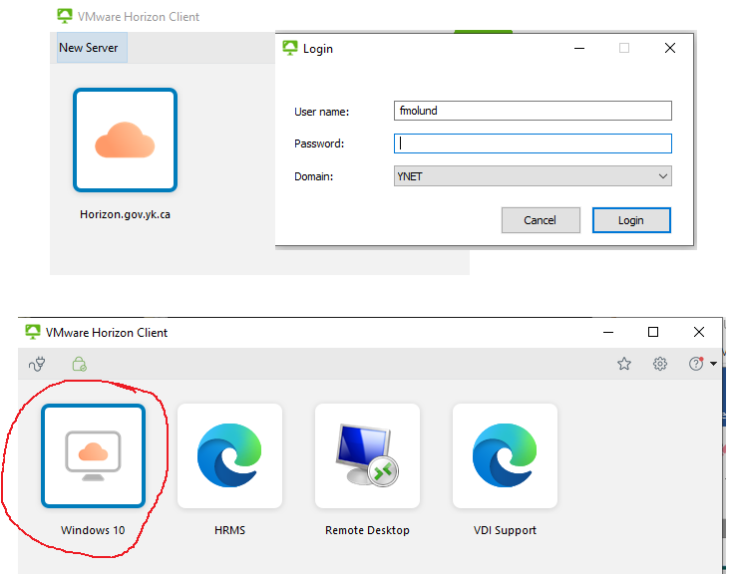

ICT Instructions
https://yukonnect.gov.yk.ca/collab/ict-c1/vmwareview/View%20Troubleshooting/How%20to%20Login%20Guides.aspx

