Check Point VPN E87.50 Install.
- Copy “CheckPointVPN_E87.50_noSDL_2FA.msi” from https://emr-ftp.gov.yk.ca/emrweb/Informatics/VPN/ to the client PC.
CheckPointVPN_E87.50_noSDL_2FA.msi = No Secure Domain Logon

- Run the chosen msi as an administrator.
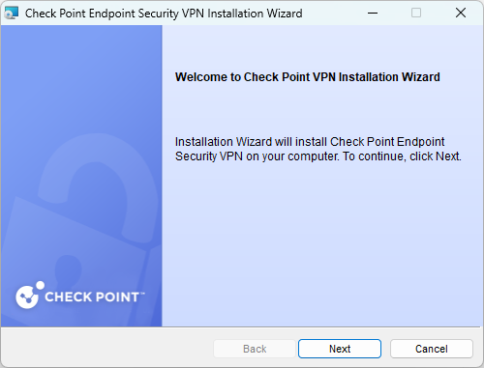

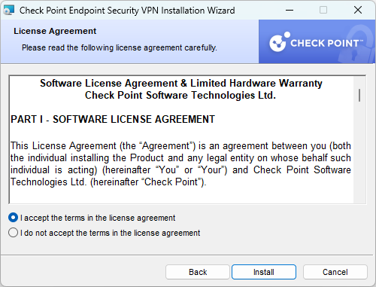
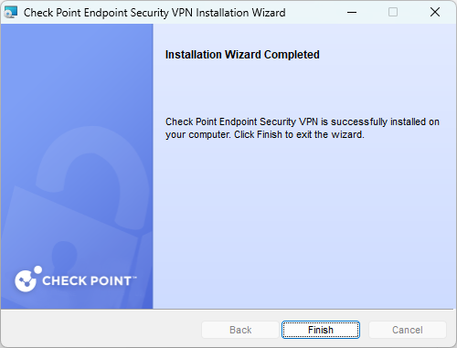
- Two sites will be created.
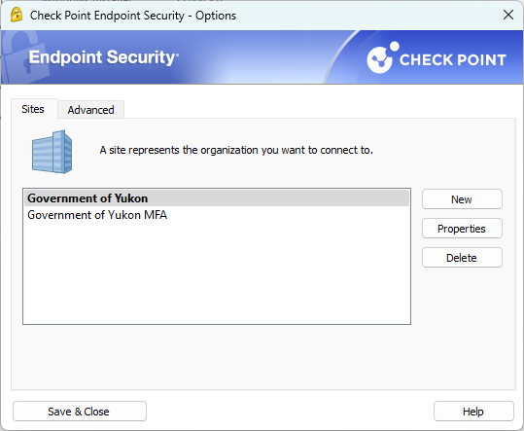
Government of Yukon = Standard Radius Authentication
Government of Yukon MFA = SAML authentication with EntraID. Users must be enrolled in Azure MFA for this option. This will be default/only option at some point.

