**Step 1. Setting up VPN on Mac**

1. Go to the link

<https://emr-ftp.gov.yk.ca/emrweb/Informatics/VPN/Mac-Install/>

1. Click on connect

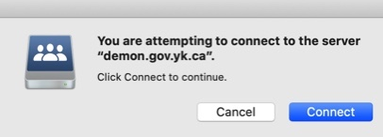

1. Allow page to open in finder



1. Enter password

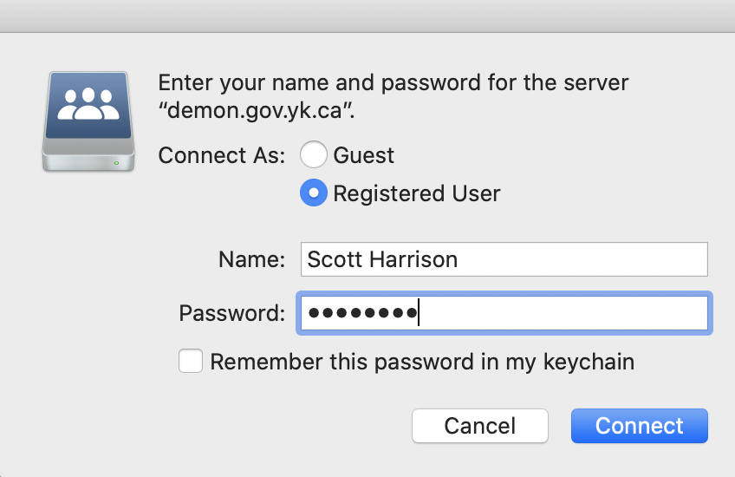

1. Double click on the endpoint security for macOS

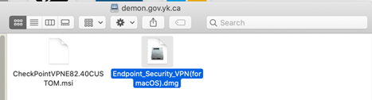

1. Double click the package to run select continue

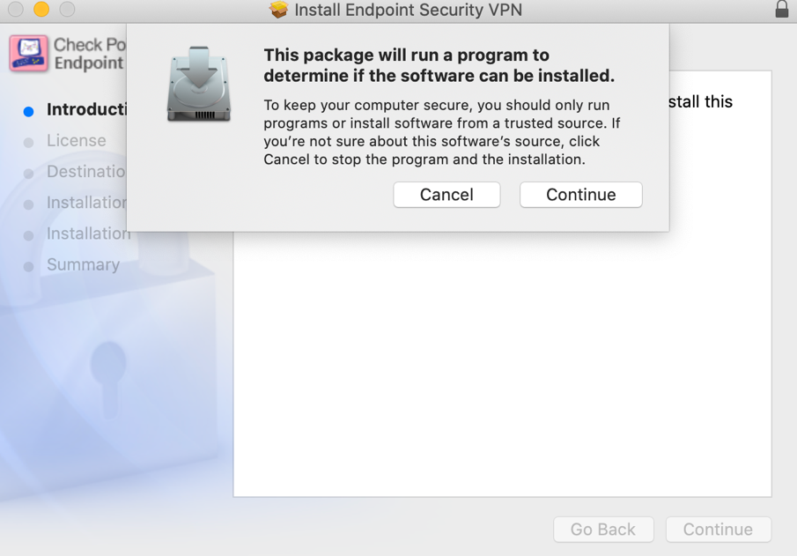

1. Click continue until you get to this screen and then click agree

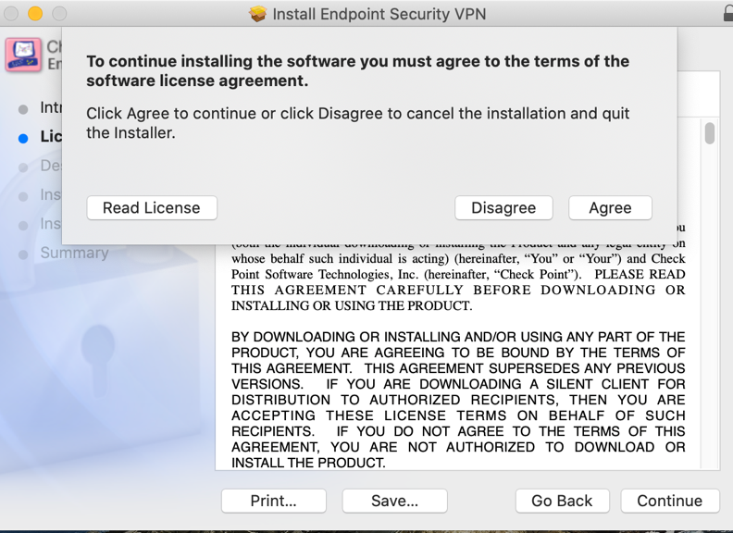

1. Click install

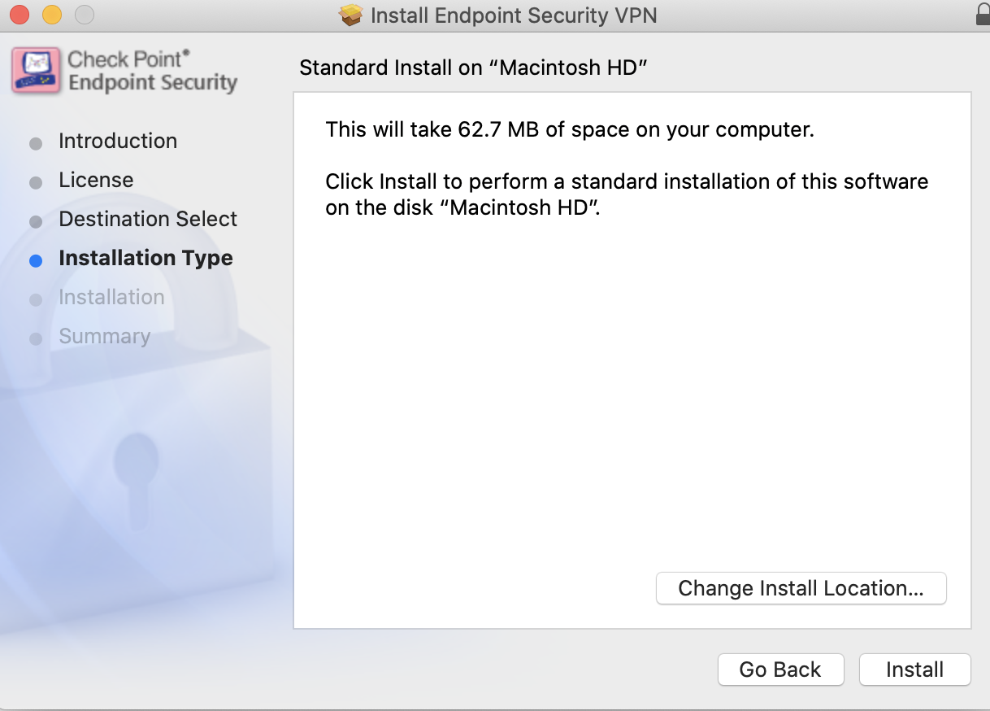

1. Click use password

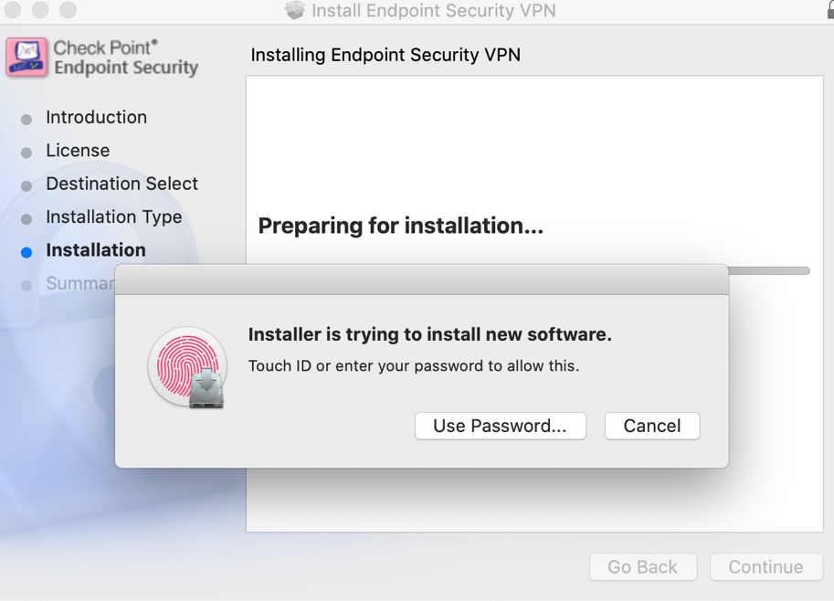

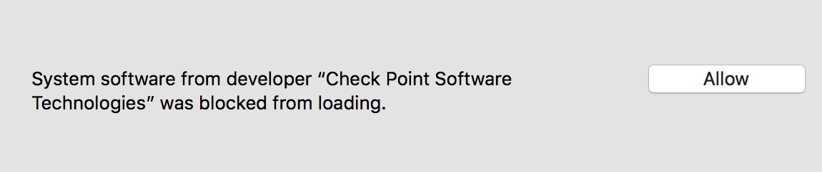

1. Click **Allow**, then reinstall the client application by launching the **EndPoint_Security_VPN.pkg**. You should see the following window. Click on the **New** button.

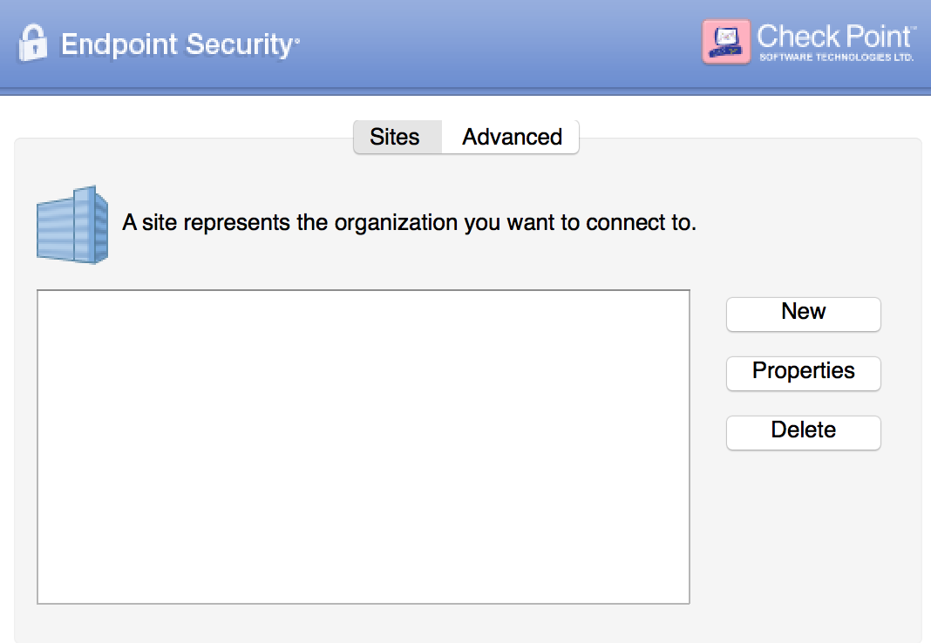

1. The Site Wizard will guide you through setting up the gateway. Click the **Next** button to advance to the **Server Address or Name** field. Click in the empty field box and enter **vpn.gov.yk.ca**.

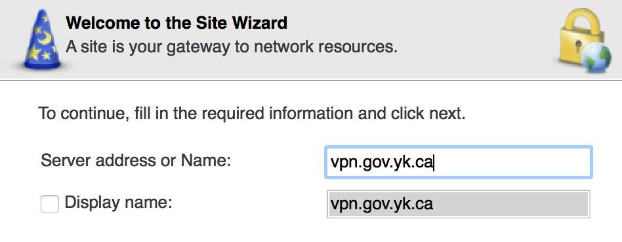

1. Click on the **Next** button to advance to the Authentication Method window. Click on the **Username and Password** radio button.

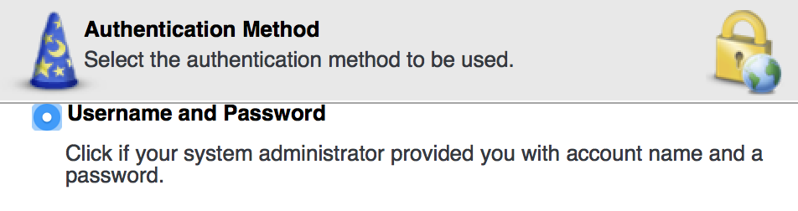

1. Click on the **Next** button, then click on the Finish button. You will now be asked if you want to connect:

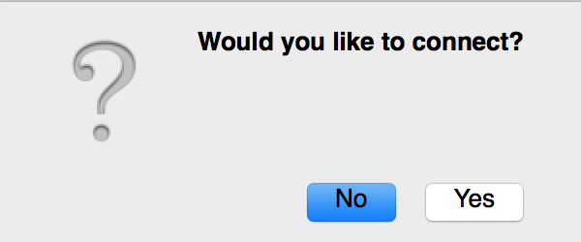

1. Click **Yes** to connect and you will be asked to enter your Username and Password. For Username, enter as *domain\username* as in the example:

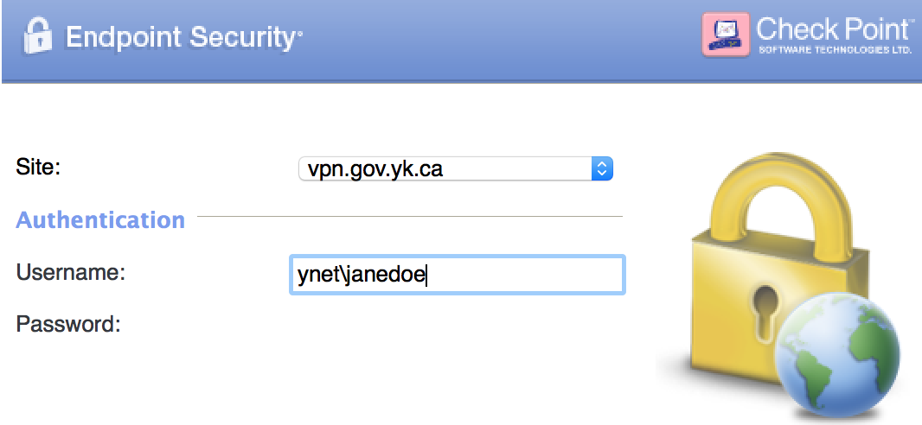

Welcome to your VPN connection to YG.

**Step 2. Microsoft Remote Desktop Connection.**

To be able to remote into your work PC once you have the Endpoint VPN software setup you will need to download, install, and use the “Microsoft Remote Desktop Connection” app from the app store.

1. Start the Microsoft Remote Desktop App put the name of your work PC in the PC Name field. You might have to add YNET.GOV.YK.CA to the username example Y212345.ynet.gov.yk.ca
2. For the User Account use the username you use to log onto your work PC and add YNET\ in front of it. For a username of “jsmith” it would be YNET\jsmith.

