**Check Point VPN Software Install:**

Download the Software at the site below:

<https://emr-ftp.gov.yk.ca/emrweb/Informatics/VPN/>

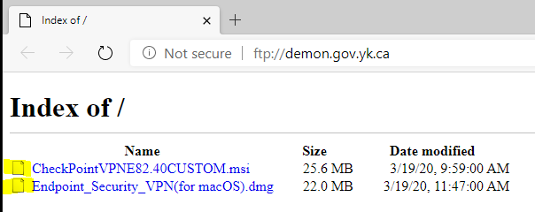

* Download the “CheckPointVPNE82.40Custom…” file for Windows PCs.

Windows 7 is a minimum to run this software Windows XP will not work.

* Download the “Endpoint_Security_VPN(for macOS)” file for Mac computers.

Another document will be coming out shortly to assist any Mac users in using VPN the rest of the instructions will be focused on the Windows install.

**Check Point for Windows Install:**

1. **Download File:** When you download the file from the site you will likely get a warning message about downloading an executable file click on the option to download it anyway. The File Should be in your downloaded files folder on your computer.

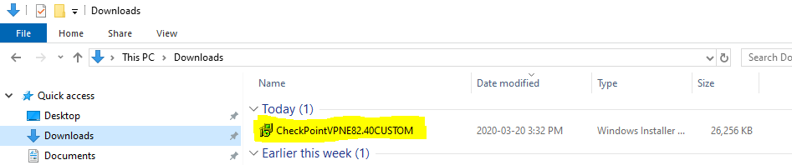

1. **Run the Install File:** Double click on the file to run the install setup. If a warning message pops up when you try run the program ignore that one as well.

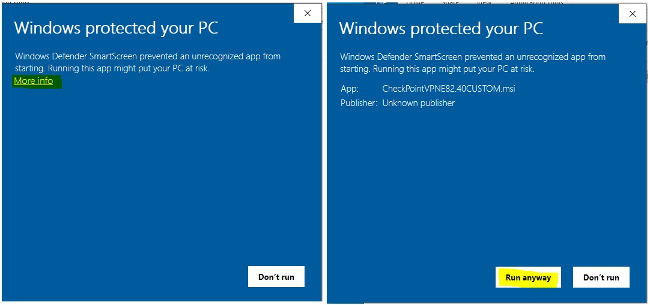

1. **Run with Defaults:** Select the default for installing the VPN software.

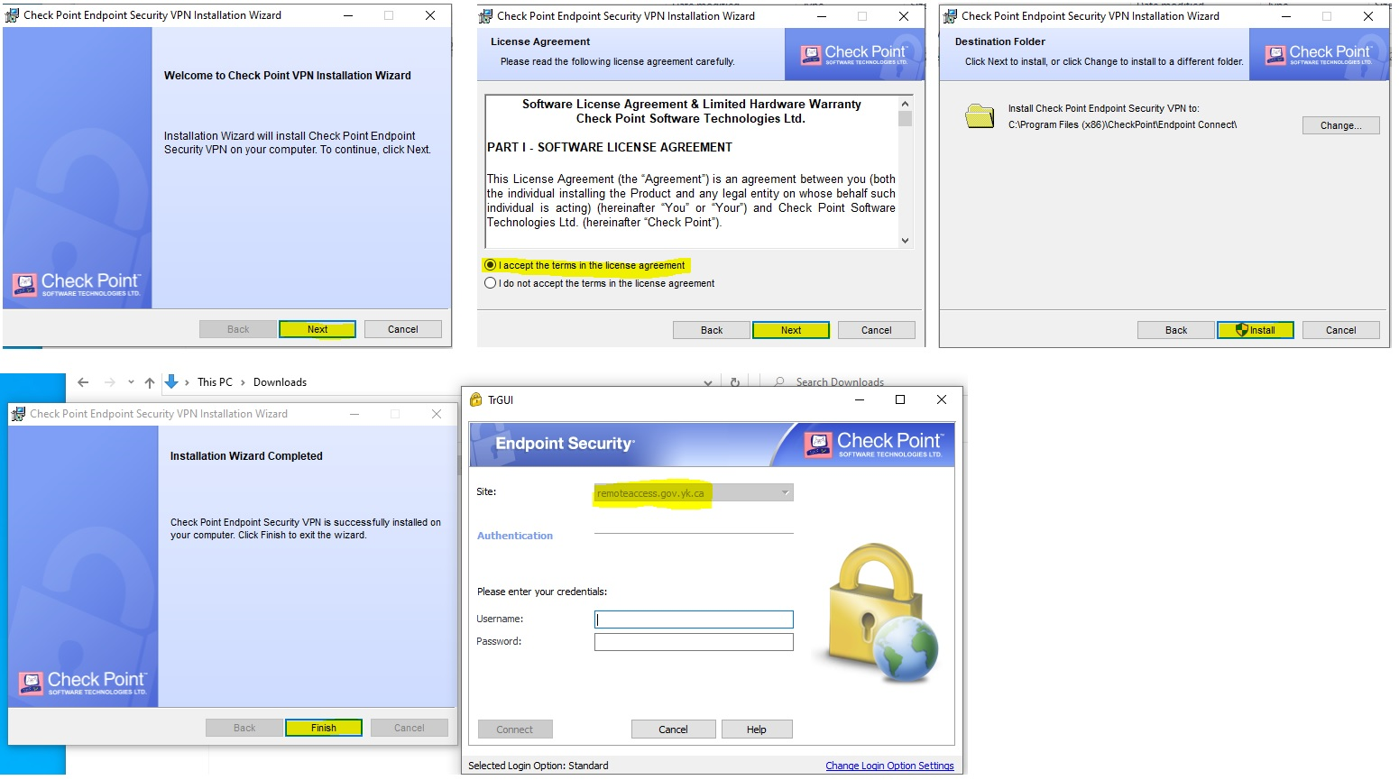

1. **Input User Information:** When the program finishes installing you will get the “Endpoint Security” logon page pop up. Use the username you use to log onto your PC at work but add “ynet\” in front of your username. Use the normal password you use to log on at work.

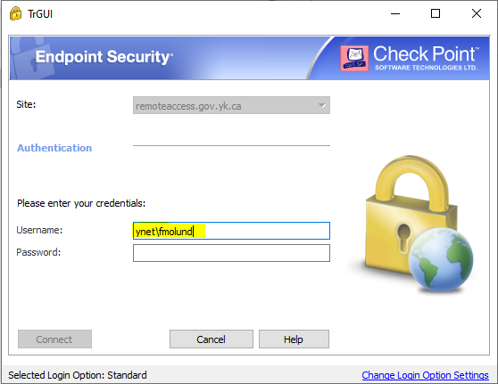

Once you are logged onto the Check Point VPN connection the VPN app can be found on the lower right task bar.

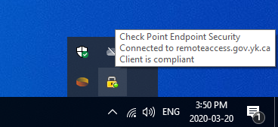

**Using Remote Desktop through Check Point VPN**

Once you have successfully connected to the VPN and have a secured connection you can use the Remote Desktop Connection application on Windows 10 and 7 to remote into your computer at work. This allows you to directly access your work computer as if you were physically there and get access to all the drives and software you have on your PC as well as any desktop files.

**Using Remote Desktop:**

1. **Finding the Remote Desktop Connection app:** In Windows 10 type “Remote” into the search bar on the lower left then either open the “Remote Desktop Connection” at or right click on it and “Pin it to the Taskbar” for easy use.

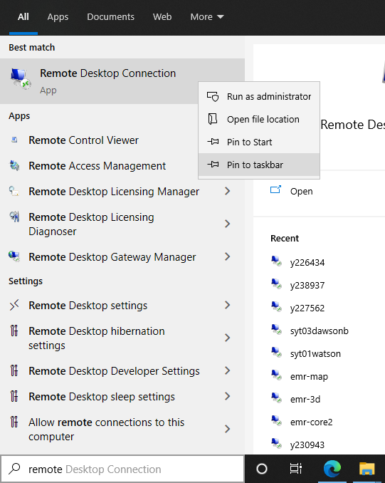

1. **Start the Remote Desktop Connection app:** Open the application and put the name of your work computer in the blank “Computer” field. ***Note*** you will have to have the name of your work computer and it must be powered on to connect to it. The name of your work computer is the same as the YG bar code that is attached to it and it will be something similar to Y225678 or IT170999. Some YG bar code stickers on the PCs are in the form of just numbers such as “001888” and the computer name for any of those adds a “Y” so the example name would be “Y001888”.

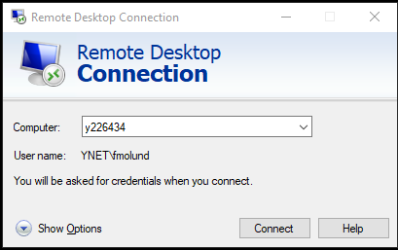

1. **Log onto Remote Work Computer:** You will be asked for a username and password to log onto your work computer. Put in your username with “YNET\” in front of it and then your password and press “OK”. You may get a certificate message after this point if so click on the “Yes” to proceed.

