**Check Point VPN Software Install:**

Download the Software at the site below:

<https://emr-ftp.gov.yk.ca/emrweb/Informatics/VPN/>

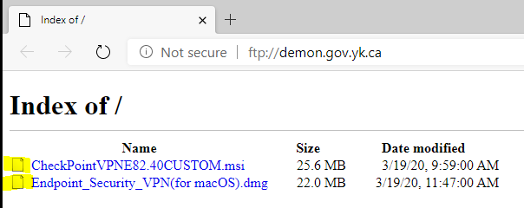

* Download the “CheckPointVPNE82.40Custom…” file for Windows PCs.

Windows 7 is a minimum to run this software Windows XP will not work.

* Download the “Endpoint_Security_VPN(for macOS)” file for Mac computers.

Another document will be coming out shortly to assist any Mac users in using VPN the rest of the instructions will be focused on the Windows install.

**Check Point for Windows Install:**

1. **Download File:** When you download the file from the site you will likely get a warning message about downloading an executable file click on the option to download it anyway. The File Should be in your downloaded files folder on your computer.

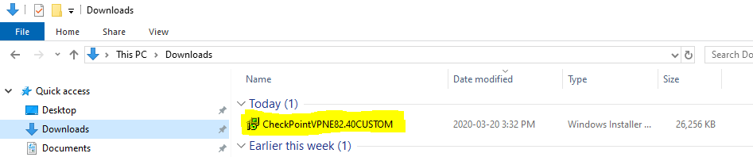

1. **Run the Install File:** Double click on the file to run the install setup. If a warning message pops up when you try run the program ignore that one as well.

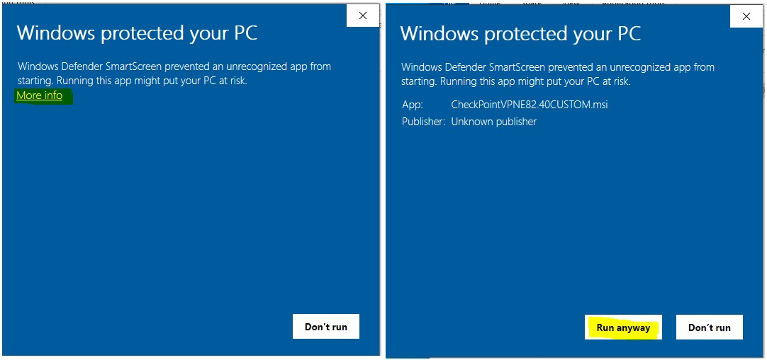

1. **Run with Defaults:** Select the default for installing the VPN software.

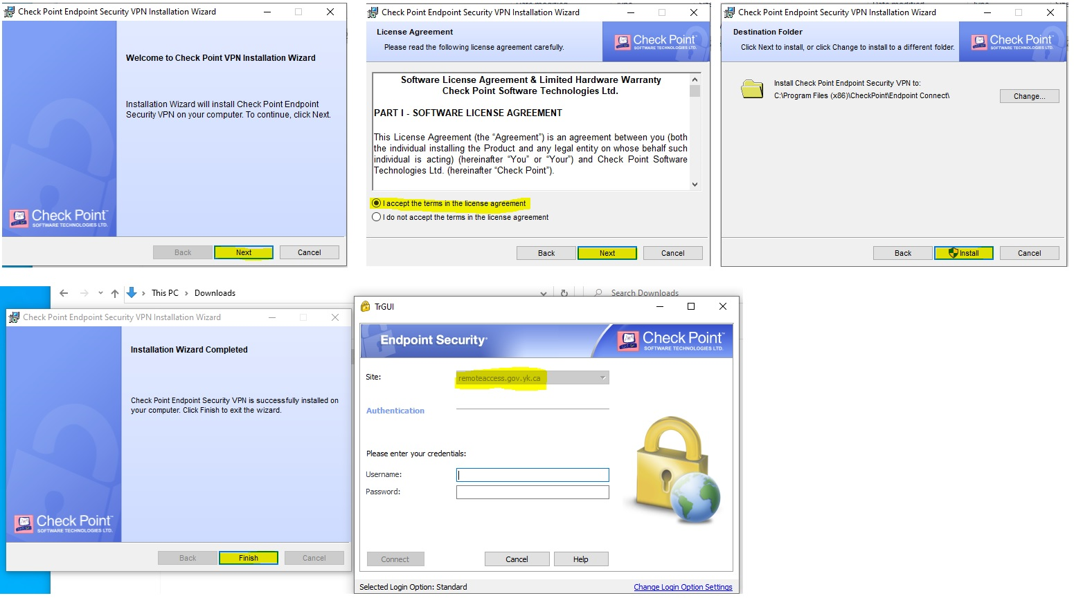

1. **Input User Information:** When the program finishes installing you will get the “Endpoint Security” logon page pop up. Use the username you use to log onto your PC at work but add “YNET\” in front of your username. Use the normal password you use to log on at work.

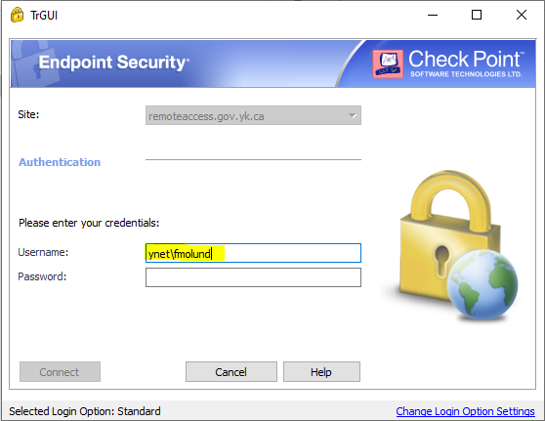

Once you are logged onto the Check Point VPN connection the VPN app can be found on the lower right task bar.

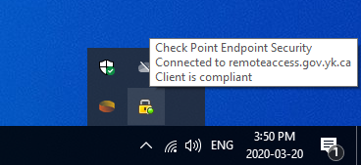

Open Windows Explorer and click on each of your drive mappings, they should “wake up” and show a green connected line instead of a small, red ‘X’

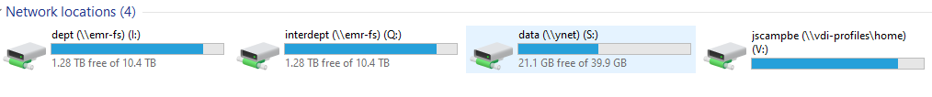

At this point, you should be able to use all of your current applications, databases and drive locations just like being in the office. It will be slower since it has to go through the firewall.

Once you are finished working, you can right click on the VPN icon in the right task bar and choose Disconnect.