Camp Winterized and Boarded up
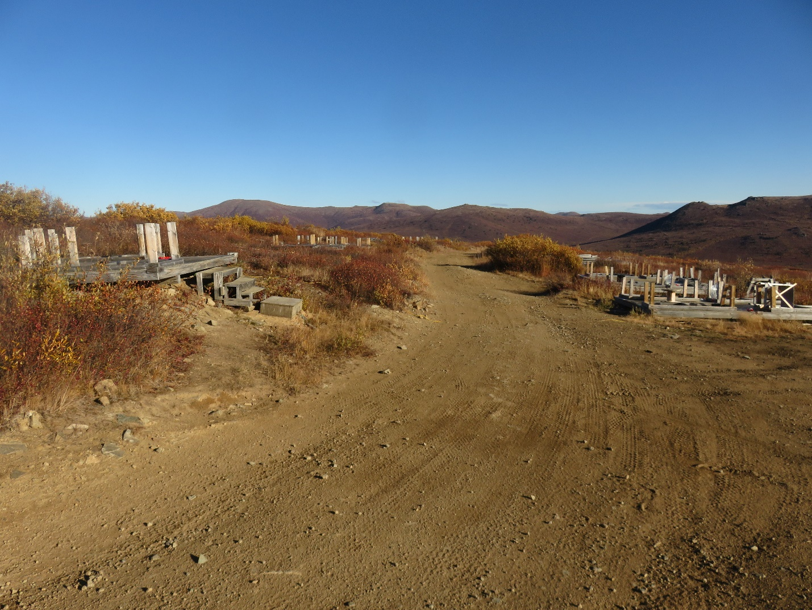

This photo was taken on September 16th, the last day onsite.
Camp is fully taken down and the wood frame structures onsite are boarded up.

