KLAZA 2022 RECLAMATION

Shown below are 2 of the numerous sites that were reclaimed this year. Photos are before/after shots to show how pads look before and after reclamation.
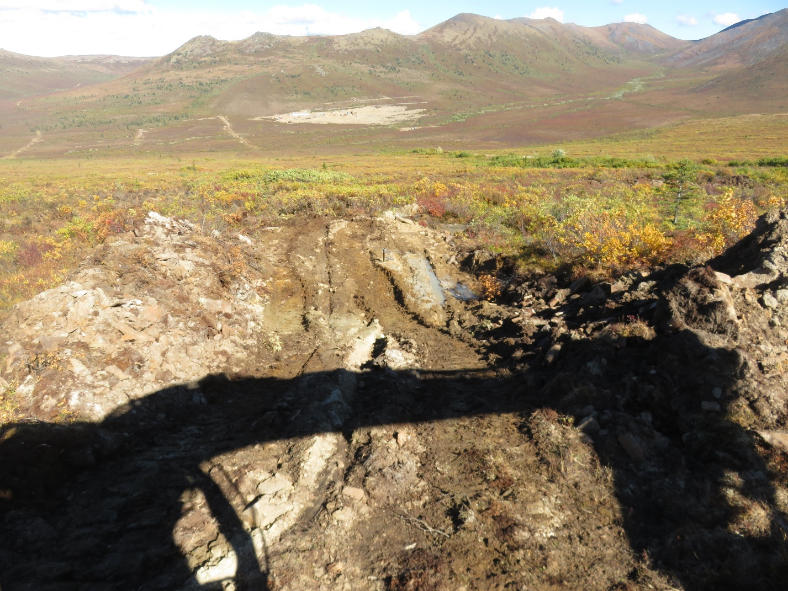
Pad 1 before reclamation
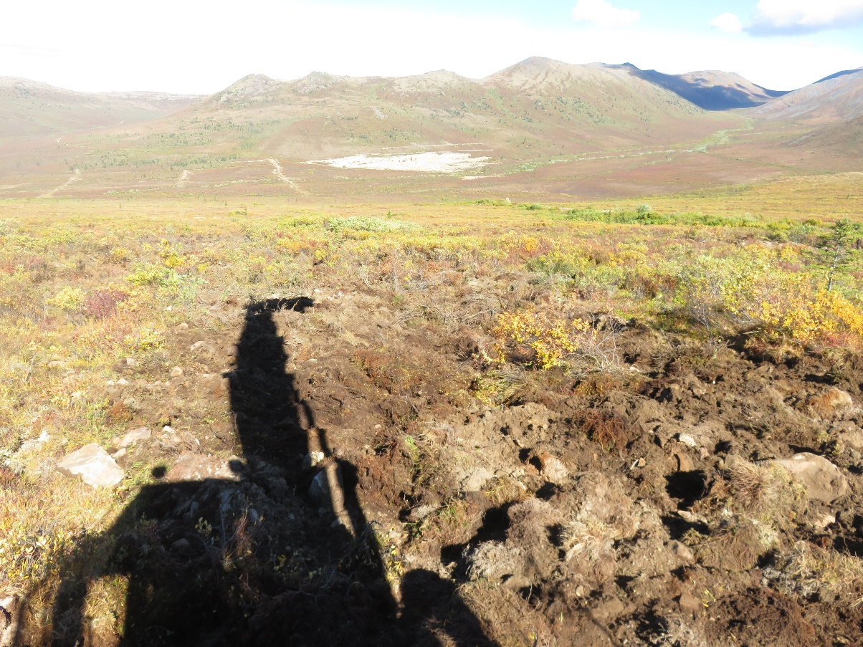
Pad 1 fully reclaimed
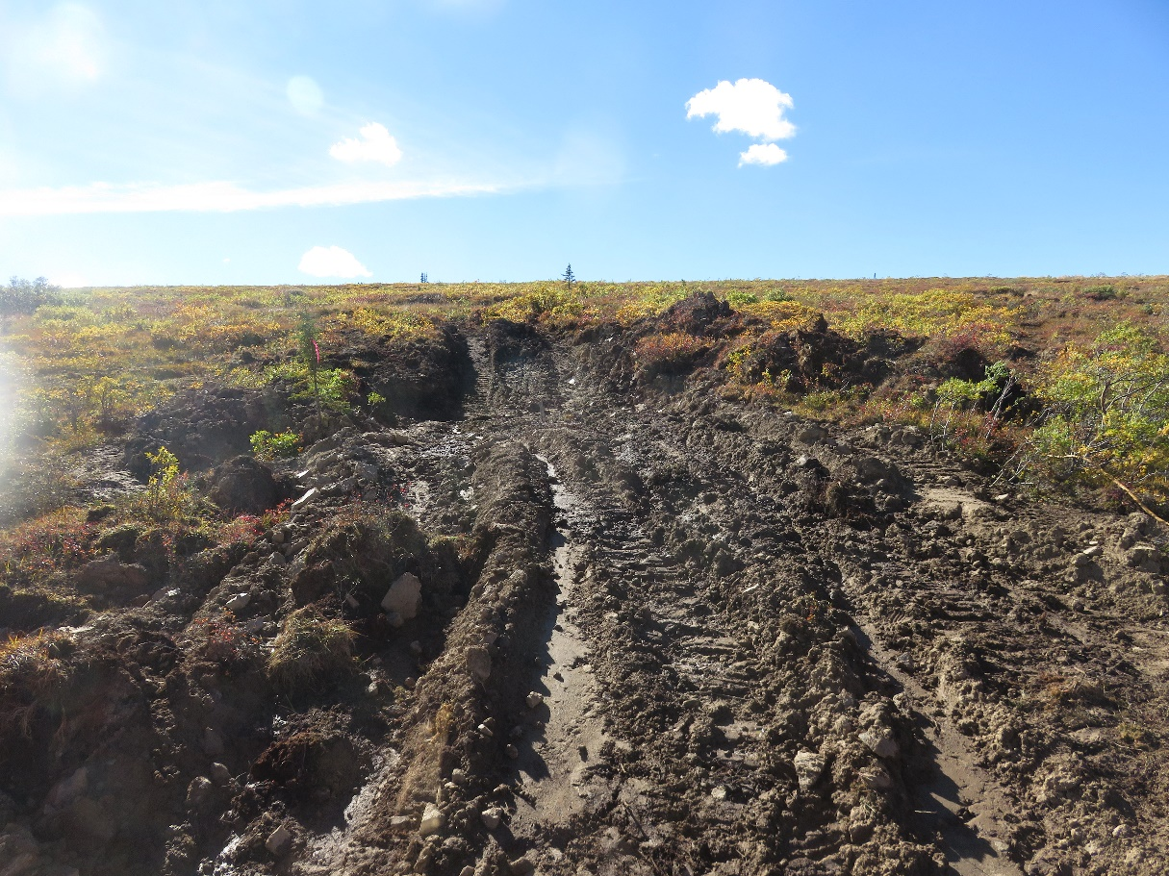
Pad 2 before reclamation
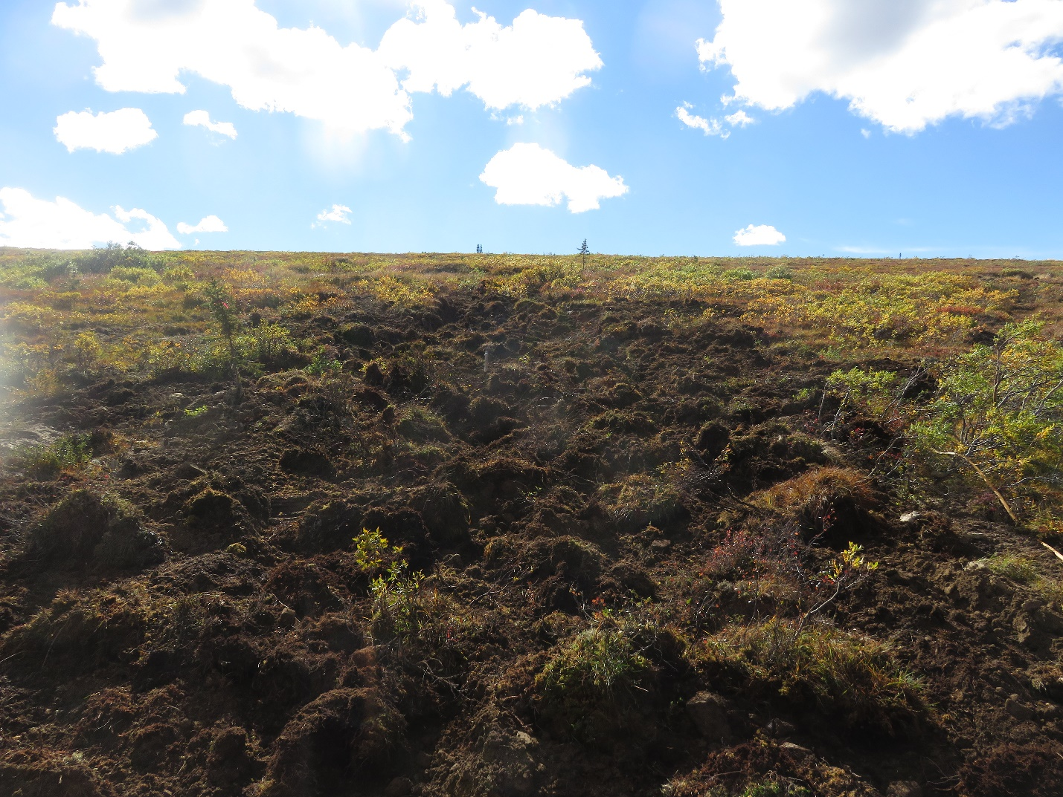Pad 2 fully reclaimed

