
Toronto Office Phone: (416) 304-9315
Suite 2550 Fax: (416) 583-2438
100 King St. W
Toronto, ON. www.nickelcreekplatinum.com
M5X 1A4 info@nickelcp.com

2022 Post-Season Report

To: Mining Lands Office
RE: Post-Season Report for Class 4 Mining Land Use Permits: LQ00468
Date: Nov. 29, 2022
From: 0905144 B.C. Ltd. (100 % - owned subsidiary of Nickel Creek Platinum Corp., formerly Wellgreen Platinum Ltd.)

Mining Lands Officer
Energy Mines and Resources
Yukon Territory

Nickel Shäw Project Deposit (Wellgreen Deposit) Centre: 577,600E, 6,815,900N
Nickel Shäw Lower Camp Facilities Centre: 589,400E, 6,820,700N
Coordinates in: UTM NAD83 Zn: 7N
Map Sheet: 115/G

This is a Post-Season Report for the Nickel Shäw Project (formerly Wellgreen Project) outlining the exploration activities carried out during the 2022 field season under the Class IV Mining Land Use Permit LQ00486. The 2022 exploration program at Nickel Shäw began with mobilization on June 30, 2022. Field activity ceased in early November. Field activities included:
- 1,711 m of HQ drilling (8 holes) on the Wellgreen Deposit
- Refurbishment of historic drill trails at the Wellgreen Deposit (grading and safety berms)
- Slotted PVC installed in 6 holes Wellgreen holes for hydrogeology surveys
- 1,260 m of NQ drilling (10 holes) on the Arch Exploration Target
- Refurbishment of historic drill trails at the Arch Target (grading and safety berms)
- Construction of 575 m of drill trail extensions at the Arch Target
- Borehole EM surveys on 4 holes (3 at Wellgreen and 1 at Arch)
- 10-line 3,000 m geophysical (Electromagnetic) survey at Arch
- Sampling of historic Wellgreen core at the Lower Camp
- 7 geotechnical RC drill holes completed on the proposed waste rock storage area

All project personnel were accommodated at the Lower Camp facility that was also used for core logging and office functions.

An aerial inspection of the project site by Yukon Energy Mines and Resources took place in mid-October.

Figure 1: 2022 Nickel Shäw Project Work Locations

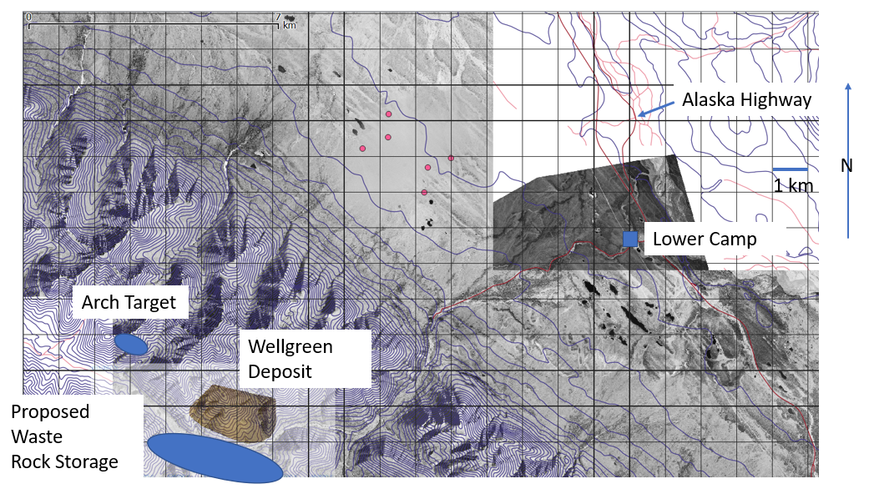

Diamond Drilling Program

Diamond drilling was contracted to Superior Diamond Drilling. A Multipower Discovery 2 Drill was utilized for the drilling. Mercer Contracting supplied the D7 bulldozer that was used to move the drill and ancillary equipment. All the drilling at Wellgreen utilized existing drill trails for access. 575 m of drill trail extensions were constructed at Arch using the D7. HQ core was drilled at the Wellgreen Deposit and NQ core was drilled at the Arch Target. 8 holes totalling 1,711 m were drilled at Wellgreen (see Table 1) and 10 holes were drilled at Arch totalling 1,260 m (Table 2). Drill hole locations at Wellgreen and Arch are shown on high resolution aerial photos below (Figures 2 and 3). All drill sites were cleaned of debris after each hole. A wood drill platform from 2022 remains adjacent to the collar site of ASD22-014-16. This material was left to facilitate construction of future helicopter-access drill platforms.

Figure 2: Wellgreen Deposit Drilling Locations

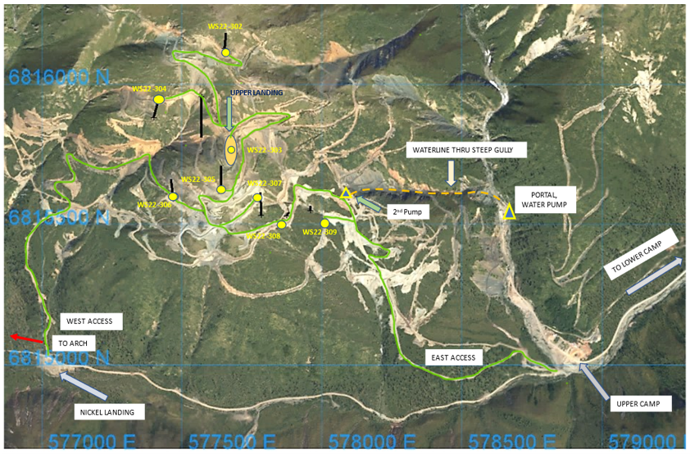

Table 1: Wellgreen Deposit Drilling summary (UTM NAD83 Zn: 7N)

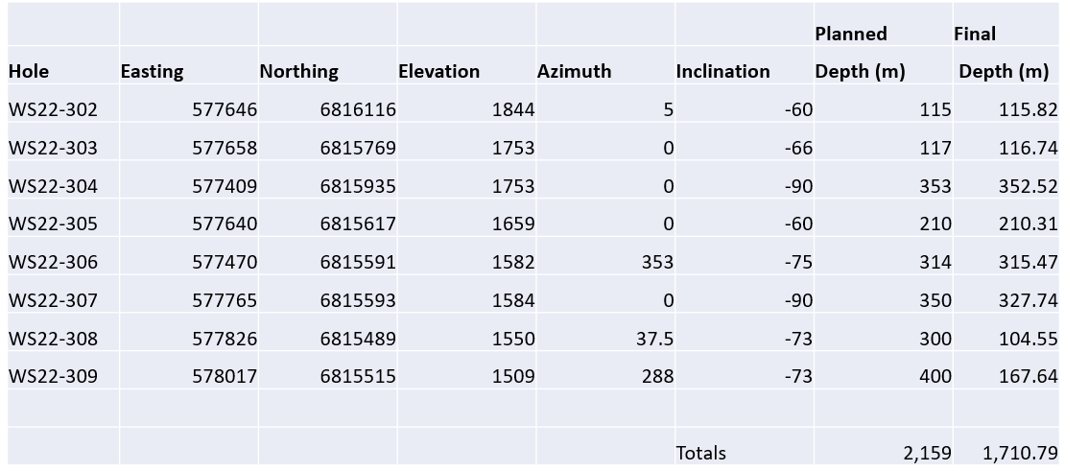

Figure 3: Arch Target Drilling Locations (drill trail extensions are shown in white)

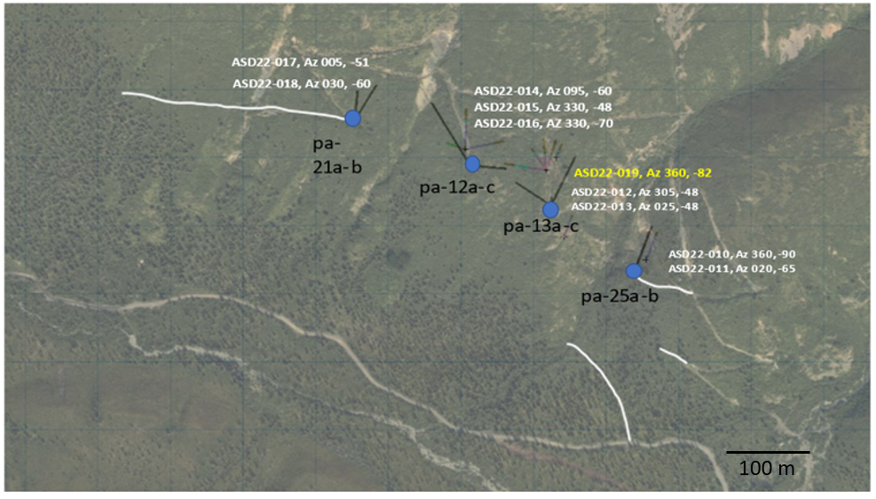

Table 2: Arch Target Drilling Summary (UTM NAD83 Zn: 7N)

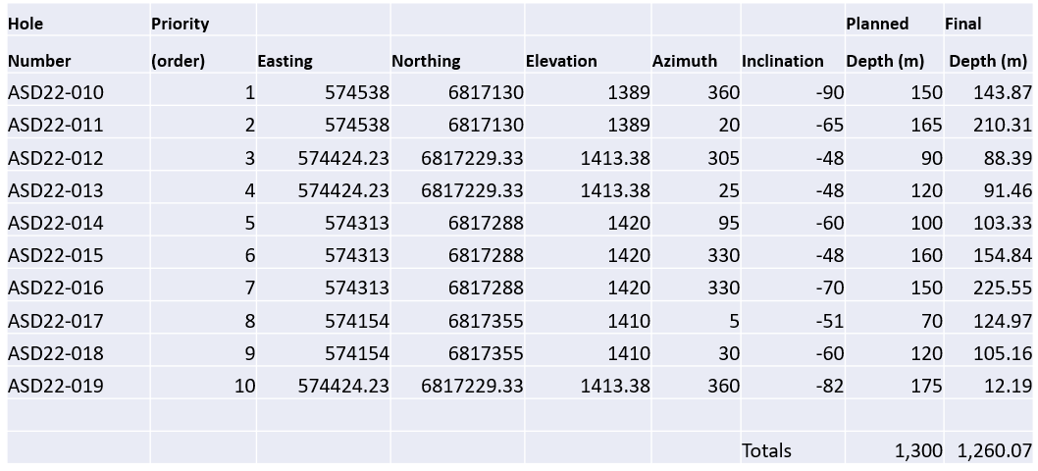
Core logging, core cutting and sampling took place at the Lower Camp. The core from all 2022 drill holes is stored at the Lower Camp in sea containers, the Lower Camp yard or the camp dry/shop building.

Geophysical Program

A ground-based borehole geophysics (electromagnetic) program was carried at the Wellgreen Deposit and the Arch Target. The Wellgreen portion of the survey consisted of 3 borehole surveys, while the Arch survey consisted of surface lines and 1 borehole survey. Figure 4 shows the area of the Arch geophysical survey. The Arch surface survey consisted of 10 surface lines totalling ~3,000 m. Crews and gear were deployed to and from the target areas by truck. All loop wire used was retrieved at the end of the survey.

Figure 4: Arch Target Geophysical Survey

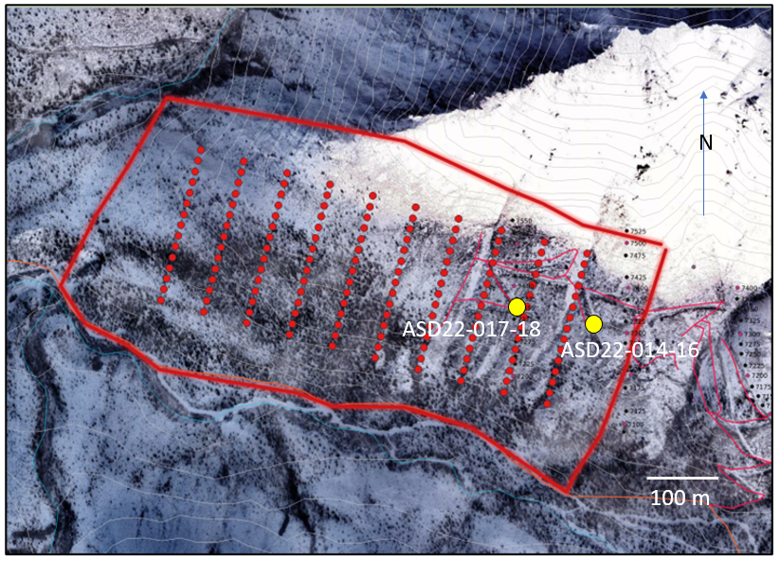

Reverse Circulation (RC) Drilling

Reverse circulation (RC) drilling was completed on 7 holes (see Figure 5 for locations) to characterize overburden and bedrock interface in the area planned for rock waste storage. Drilling was carried out by Visionquest using 4-inch diameter rods. All holes were situated in existing or natural clearings

Figure 5: Proposed Waste Storage Area Geotechnical Hole Locations Map (UTM NAD83 Zn: 7N)

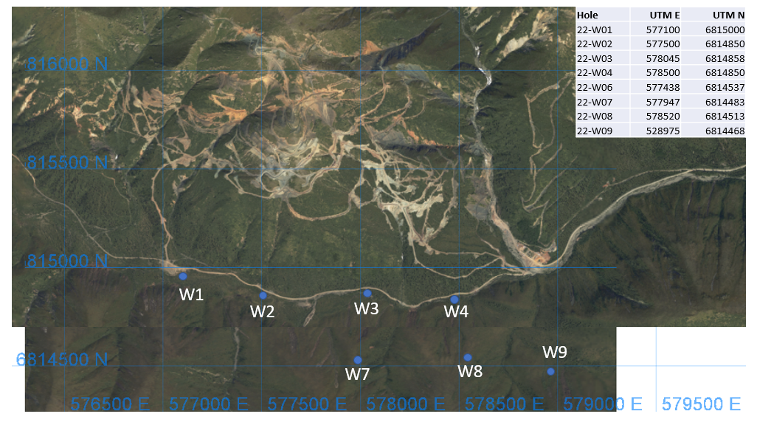

POST-SEASON REPORT

Operations Summary
Date: Nov. 29, 2021
Operating Plan: LQ00468
Name: 0905144 B.C. Ltd. (100%-owned subsidiary of Nickel Creek Platinum Corp.)
Address: 100 King Street West, Suite 2550
Toronto, ON M5X 1A4
Phone: 1.416.304.9315
Fax: 1.416.583.2438
E-mail: cbell@nickelcp.com
Start date: June 30, 2021
Approximate end date: Nov. 7, 2021
Activities: Drilling, Geophysics
Construction of lines: No lines were cut for the 2022 EM survey
Construction of corridors: (width) None Required; (length) None Required
Trenching: (total volume/ claim) None Required
Clearings: 12 clearings (mostly in previously cleared areas)
Purpose of clearings: Drill pad
Surface area of each clearing: ~10 m x 8 m
New access roads: total length: None required
Upgrading roads: total length: None required
New trails: 575 m of drill trail extensions on the Arch Target
Off-road use: total length none required; gross weight of vehicles to be used N/A
Use of explosives: amount to be used in a 30-day period: None required
Construction of underground structures: (amount of material to be moved to surface) None Required

Reclamation:
One drill pad (wooden deck approx. 5 x 5 m) from 2021 was left at the Arch Target for use in 2023. All other drill sites were reclaimed with removal of lumber, fuel, drill rods, drilling mud, misc. trash, etc.. Any soil contaminated by minor spills (< 5 litres) of fuel or oil was removed and stored in a designated drum at the Lower Camp for later disposal at an approved site.

The scrap wood pile at the Lower Camp was burned and recontoured (by bulldozer) in early October. All material from the scrap metal pile at the Lower Camp was moved (by excavator and dump truck) to the Destruction Bay Landfill site in late October.

Other information:
Utilized existing roads/trails for travel by light vehicle (on roads/trails). A replacement door was installed on the outer adit entrance of the historic Wellgreen underground mine.

Yours Very Truly,

0905144 B.C. Ltd (Nickel Creek Platinum Corp.)

______________________________________
Cameron Bell P.Geo.
Consulting Geologist

